SQL Exercise 6
1. Display all the Suppliers with the same Status as the supplier, ‘CLARK’.
- Select * from S
-> where Status = (
-> Select Status from S
-> where sname = 'Clark'
-> );
Empty set (0.06 sec)
2. Display all the Employees in the same department as the employee ‘MILLER’.
- Select *
from Emp
Where Deptno = (
Select Deptno
From Emp
Where Ename = ‘Miller’
);
3. Display all the Parts which have more Weight than all the Red parts.
- Select * from P
-> Where Weight > ALL (
-> Select Weight from P
-> Where color = 'Red'
-> );
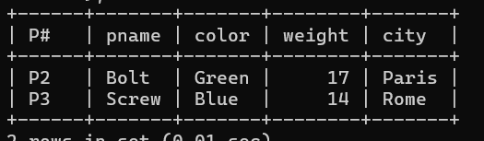
4. Display all the Projects going on in the same city as the project ‘TAPE’.
- Select * from J
-> where City = (
-> Select City from J
-> where jname = 'TAPE'
-> );
Empty set (0.00 sec)
5. Display all the Parts with Weight less than all the Green parts.
- Select * from P
-> Where Weight < all (
-> Select Weight from P
-> where P.color = 'Green'
-> );

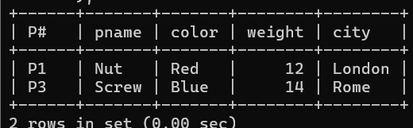
6. Display the name of the Supplier who has sold the maximum Quantity (in one sale).
- Select Sname from S
-> Join SPJ on S.`S#` = SPJ.`S#`
-> Where SPJ.Qty = (
-> Select Max(qty)
-> from SPJ );
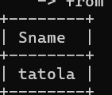
7. Display the name of the Employee with the minimum Salary.
- Select Ename form Emp
-> Where Salary = (
-> Select min(Salary)
-> from Emp
-> );
8. Display the name of the Supplier who has sold the maximum overall Quantity (sum of Sales).
9. Display the name of the Department with the maximum number of Employees.
- Select D.Dname from Dept D
-> Join Emp E on D.Deptno = E.Deeptno
-> Group by D.Deptno, D.Dname
-> Having Count(*) = (
-> Select Max(emp_count)
-> from (
-> Select Count(*) from Emp
-> Group by Deptno
-> ) as Temp
-> );

